**“Bruised brains” by Cate McQuaid, Boston Globe Staff 3/15/2012**

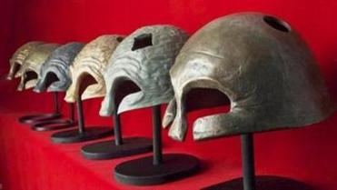

Ken Hruby’s sculptures from his exhibit “Trepanation.”

Sculptor Ken Hruby, a veteran of the wars in Korea and Vietnam, has for years made work about warriors. "Trepanation," his show at NK Gallery, delves into traumatic brain injury. Trepanation is a surgical procedure involving removing a portion of the skull in order to alleviate pressure when the brain is swollen.

For two series, "Wounded Warrior" and "Worried Warrior," Hruby has cast the form of an ancient helmet in a variety of materials, some with small sections cut out. The translucent ones, in glass and lead crystal, shine as they perch over light boxes. Many ripple, their surfaces echoing that of the brain. Each conveys a different emotional tone. Metal ones come with a rubber hammer; strike the helmet and it rings, a feature that mimics the tinnitus that afflicts many with brain injuries.

The group suggests a small troop, or perhaps the patients on a hospital ward. The helmets feel protective and exposed, noble and damaged.